I. Complete the short answers.

Example:
Do you live here? Yes, I do.

- Have you got any children?
Yes, .......................................................
- Is that boy your son?
Yes, .......................................................
- Does your brother like golf?
No, .......................................................
- Were they at home yesterday?
No, .......................................................
- Did your parents go with you?
Yes, .......................................................
- Did you have a party?
Yes, .......................................................
- Was the weather OK?
Yes, .......................................................
- Are you going to play football today?
No, .......................................................
- Do your friends like healthy food?
Yes, .......................................................
- Were your mates at the sports centre?
No, .......................................................

II. Complete the story with the verbs in
the boxes. Use the past simple.

stay miss not like
think can´t not be

Emma is 14 years old. She comes from Plant City in the USA. Last year she ..stayed.. in Britain for a year. At first she ...............(1) it very much. She ..............(2) the people .................(3) very friendly. Sometimes she ..................(4) understand them! She ................(5) her family and friends in the USA.

start have not want come play
ask go not be say meet

But then things ................(6) to get better. She ...............(7) a boy called Tom. He .............(8) from Canada. Tom ..............(9) Emma to go out and she .............(10) “yes”. For one month they ................(11) a great time. They .................(12) tennis and
volleyball together. They ................(13) to a lot of parties too. Life ............(14) so bad after all! Then the school year finished. Emma ....................(15) to go home.

III. Complete the conversation. Put the
verbs in brackets into the correct
tense (present simple or present
continuous).

Mum Are you all right Jack?
...Are you studying...(you/study) at
the moment?
Jack No, Mum. We ..............................(1)
(not write) tests on Mondays.
Mum I can hear music. .........................(2)
(you/play) the guitar?
Jack No, it´s the neighbours next door.
They often .......................(3) (listen
to) loud music in the evening.
Mum Are you sure, Jack? I think
somebody ....................(4) (dance),
too!
Jack Mum, you sometimes ...................(5)
(have) these strange ideas!
Mum Jack, ............................................(6)
(somebody/have) a party in our
house?

IV. Write the questions to complete the
interview.
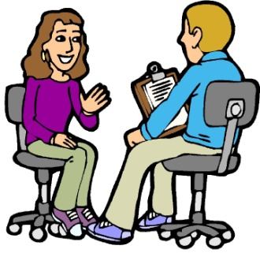

Example:
How old are you?
I´m 32 years old.

1 ................................................................?
I was born in 1980.
2 ...................................................................?
I grew up in Wales.
3 ................................................................?
I left school when I was eighteen.
4 ................................................................?
I work as a private detective.
5 ................................................................?
Yes, I do. I enjoy it.

V. Write sentences. Use the verbs and expressions in the box.

watch TV read go shopping
listen to music sleep have a shower run play golf travel write letters

Example:


She likes reading but she doesn´t like writing letters.


1 We ............................................................
..................................................................



2 He .............................................................
..................................................................



3 They .........................................................
..................................................................

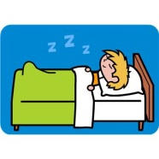
4 I ................................................................
..................................................................

KEY

I.
- Yes, I have.
- Yes, he is.
- No, he doesn´t.
- No, they weren´t.
- Yes, they did.
- Yes, I did.
- Yes, it was.
- No, I´m not.
- Yes, they do.
- No, they weren´t.

II.
- didn´t like
- thought
- weren´t
- couldn´t
- missed
- started
- met
- came
- asked
- said
- had
- played
- went
- wasn´t
- didn´t want

III.
- don´t write
- Are you playing
- listen to
- is dancing
- have
- is somebody having

IV.
- When were you born?
- Where did you grow up?
- When did you leave school?
- What do you do?/ What´s your job?
- Do you enjoy it?

V.
- We like listening to music but we don´t like watching TV.
- He likes running but he doesn´t like having shower.
- They like (going) shopping but they don´t like travelling.
- I like sleeping but I don´t like playing golf.

