Grammar – Present Tenses
- Make the questions using the prompts.

Ex.: Martin/play/the violin? Does Martin play the violin?

- Sue/live/in a block of flats?
- Where/you/usually/go/in the afternoon?
- What/Peter/do/at the weekends?
- They/learn/English?
- When/your parents/get up/on Mondays?
- What time/your school start?

- Look at the picture and write what are they doing?
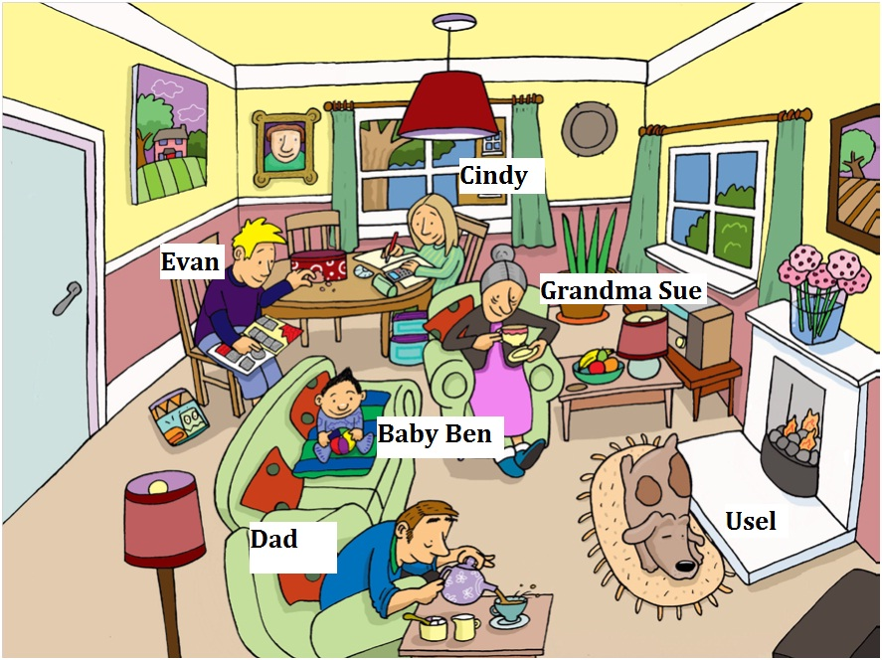
Ex.: The dog is sleeping.

- Write the negative of the sentences.
Ex.: She does her homework before school.
She doesn´t do her homework before school.
- He tidies his room every day.
- They make the beds.
- I set the table.
Key:
- a) Does Sue live in a block of flats?
b) Where do you usually go in the afternoon?
c) What does Peter do at the weekends?
d) Do they learn English?
e) When do your parents get up on Mondays?
f) What time does your school start?

- Cindy is writing her homework.
Evan is collecting some pictures.
Baby Ben is playing with ball.
Grandma Sue is drinking tea.
Dad is pouring coffee.

- a) He doesn´t tidy his room every day.
b) They don´t make the beds.
c) I don´t set the table.

