dokument má 3 strany!
Pracovní sešit + veškeré vypracované úkoly mi prosím ofocené pošlete na email: monika.fantova@zs-studanka.cz.
Poslat vyfocené do 30.3. 2020 do 9:00
- Opakování slovní zásoby a minulého času
- Práce s textem – vyhledávání slovíček + porozumění textu – odpovědi na otázky

Úkoly:
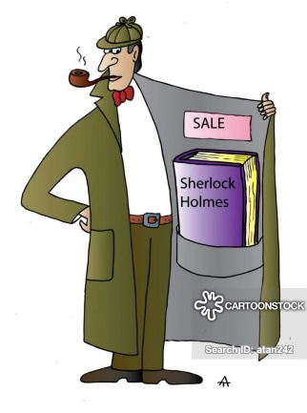
- pracovní sešit (workbook) str. 33 cv. 4 - co jste dělali v určité časy a
- str. 33, cvičení 5 – doplňte vhodné tvary sloves – bude had nebo was having, saw nebo was seeing? Je nutné dávat průběh nebo jen viděl? – ofocené zase pošlete.

3) vraťte se do textu níže, který byste měli mít nalepený v sešitě a odpovězte mi na tyto otázky:

a) Where was Donna sitting when she was watching a film?
b) What did Donna was doing when she heard a shot?
c) What is Wilson’s job?
d) What was Wilson doing when Donna saw him?

3) Přečtěte si závěr případu Johna Rosse. Napište, mi zda jste měli pravdu nebo ne. Kdo nakonec zabil Johna a proč?
Were you right about the person who killed John Ross?
Who killed him?
Why? How did he/she do it? – popiš, proč, jak to udělal/a?
TEXT II:
Smart Alec: I know who killed John Ross. It wasn’t you, Adams. You were repairing the car. Miss Ross heard you. Anyway, you had oil on your hands. There was oil on the handle of the front door, but not on the gun.
Miss Ross, it wasn’t you. You were watching TV. And when you heard the shot you came out of the living room. Both Wilson and Adams saw you.
Wilson, your fingerprints were on the window and the library door. But Miss Ross saw you in the dining room. You also dropped a plate and Miss Ross heard it.
So the killer was you, Mrs Clare. You killed Mr Ross, because he wanted to get a new cook. He didn’t like your Cottage pie, did he?
Donna: But how did she do it?
Smart Alec: She went out of the back door, walked round the house, under the dining room window, then she spoke to Mr Ross through the library window. He stood up. She grabbed the gun, shot him, then dropped the gun, ran to the back door and phone the police.
Wilson: But why weren’t her fingerprints on the gun? She didn’t have time to clean it.
Smart Alec: Yes, and there were no fingerprints on the phone, because Mrs Clare was wearing rubber gloves.
Mrs Clare: All right. It’s true. I make the best cottage pie in the world, but he didn’t like it. So I killed him.
Donna: Smart Alec! You’re a genius!

4) napsání svého vlastního příběhu v minulosti!!
Inspirujte se příběhem ze str. 36
S rozsahem to nepřehánějte, tak půlka A4 bude dostatečná - napiš do wordu nebo do sešitu a pošli mi na e-mail. Ať je to čitelné prosím, kdo může spíše pište do wordu, potom si vytisknete a nalepíte do sešitu

Nejdřív svůj příběh nějak uveďte, potom představte postavy, kdo co dělal v čas vraždy a až nakonec okomentujte, kdo to udělal, proč a jak Nezapomeňte na kritéria!

Criteria:
- Story in the past
- Facts/actions – in the past
- When/while
- Vocabulary – 5 words from our vocab list – as fast as possible, sink, handle of the door, etc.

- Introduction of the story present + past
- Characters – who?
- Use the vocab – as fast as possible, sink etc. 5 words at least
- Use the plan of your house – the kitchen, the living room
- What was each person doing at the time of murder? - co každá ta postava dělala v čase vraždy?
- who did it?
- how?
- why?

