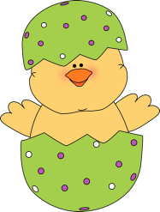
Write three words in each category! Name: _______________ Score:_______

Three Easter Days!
Easter
5
A Minute Activity
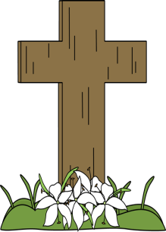
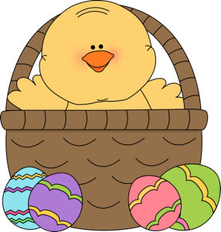
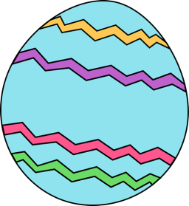
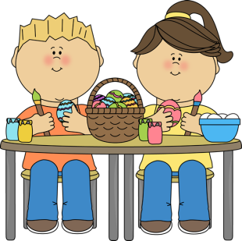
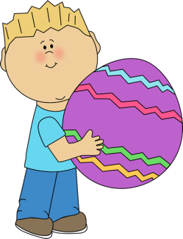

Three egg foods!

Three Easter decorations!
1

Three Easter foods!

13
7
8
9
10
12
11
6
5
4
3
2

EASTER in three other languages!
Three Easter symbols!
Three Easter games!
Three Easter characters
Three Easter traditions!
Three Easter animals!
Three Easter candies!
Three spring months!
Three Easter flowers!

