VOLUNTARY TASK – DEADLINE: 27TH APRIL
Put it into your notebook, take a photo of it and send it to my e-mail. For meeting the criteria you get extra 1

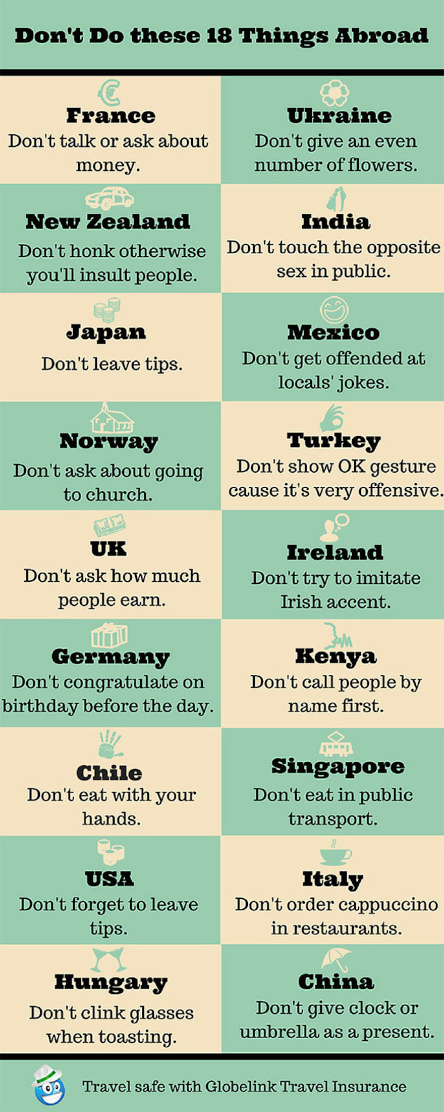
READING AND WRITING:
- CHOOSE 4 COUNTRIES
- WRITE WHAT PEOPLE – visitors- IN THESE COUNTRIES SHOULDN’T DO
- FIND ON THE INTERNET WHY – USE MIGHT
- WHAT INFORMATION DO YOU FIND SURPISING? (CO TI PŘIJDE ZAJÍMAVÉ NEBO TĚ PŘEKVAPILO)

FOR EXAMPLE:
1) Japan:
When you eat in a restaurant, you shouldn’t give any tips otherwise the waiter/waitress might get offended. (by se mohl/a naštvat)
I find the information about Japan surprising. I think not giving a tip is pretty weird.

