

Last summer, Kevin, his brothers and cousins had very interesting holidays. They went camping in the mountains. They spent a wonderful time. They usually woke up early in the morning with the birds singing and they got up feeling fresh. Before breakfast, they went for a walk.
They sometimes went to the village, where they bought what they needed. During the day they played cards, they swam in the river, they played guitar or listened to music. Kevin even had a strange adventure. They had a lot of fun.

1. Are these statements (tvrzení) True (T) or False (F)?
a. Kevin, his brothers and his cousins had very nice holidays. ______
b. They went to the seaside. ______
c. They usually wake up late in the morning. ______
d. They never went to the village. _____
e. During the day they swam in the river. ______
f. They had a lot of fun. _______





2. Answer (Odpověz) these questions. Odpovídej prosím celou větou v čase minulém.
a. Where did Kevin go last year? ____________________________________________________________
b. Did Kevin and his brother go camping in the seaside? _________________________________________
c. What did the usually do before breakfast? __________________________________________________
d. Where did they what they needed? _______________________________________________________
e) Did Kevin have a strange adventure? ______________________________________________________

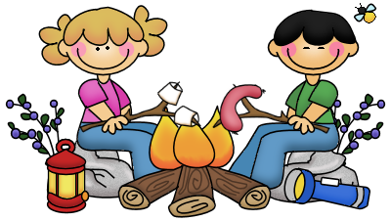

3. Complete (Doplňte) this list (seznam) with other verbs (slovesy) in the simple past, taken from (vzaté z) the text.

had _______________________ ______________________
went _______________________ ______________________
spent _______________________ ______________________

5. Write negative (zápor) sentences.

a. They went camping in the mountains. ___________________________________________________
b. They sometimes went to the village. ____________________________________________________
c. They had a lot of fun. ________________________________________________________________
d. During the day they played cards. _____________________________________________________
e. They swam in the river. _____________________________________________________________
f. Kevin had a strange adventure. _______________________________________________________
4. Put the verbs in brackets (závorky) in the past simple.

Last year Kevin and his cousins ________________ (discover) a cave. They ________________(be) inside it when they ________________(hear) a strange noise.
At first Kevin ________________(think) it ________________ (be) a baby crying, but it ________________(not be). He ________________ (find) a baby eagle with a broken wing.
He ________________(take) it to the vet and some days later the eagle ________________ (can) already fly.

